Human Motion Detection System Using PIR Sensor and Arduino for Smart Security
A CAPSTONE PROJECT REPORT
Submitted in the partial fulfilment for the Course of
ECA0711-TRANSDUCERS AND SENSORS FOR NAVIGATION SYSTEMS
to the award of the degree of
BACHELOR OF ENGINEERING
IN
ELECTRONICS AND COMMUNICATION ENGINEERING
Submitted by
G.Manoj (192312234)
G.Chandu (192312154)
Under the Supervision of

Dr.BENISHA CHRIS A

SIMATS ENGINEERING
Saveetha Institute of Medical and Technical Sciences
Chennai-602105
July 2025



SIMATS ENGINEERING
Saveetha Institute of Medical and Technical Sciences
Chennai-602105

DECLARATION

We, [G.Manoj (192312234) and G.Chandu (192312154)] of the [E.C.E], Saveetha Institute of Medical and Technical Sciences, Saveetha University, Chennai, hereby declare that the Capstone Project Work entitled ‘[Human Motion Detection System Using PIR Sensor and Arduino for Smart Security]’ is the result of our own bonafide efforts. To the best of our knowledge, the work presented herein is original, accurate, and has been carried out in accordance with principles of engineering ethics.

Place: Chennai
Date: 15/07/2025

Signature of the Students with Names

SIMATS ENGINEERING
Saveetha Institute of Medical and Technical Sciences
Chennai-602105

BONAFIDE CERTIFICATE

This is to certify that the Capstone Project entitled “Human Motion Detection System Using PIR Sensor and Arduino for Smart Security ” has been carried out by [G.Manoj(192312234) and G.chandu (192312154)] under the supervision of [Dr. Benisha chris.A] and is submitted in partial fulfilment of the requirements for the current semester of the B.Tech [E.C.E] program at Saveetha Institute of Medical and Technical Sciences, Chennai.

SIGNATURE SIGNATURE
Dr. A. Benisha chris
Department Name (ECE) Department Name ()
Saveetha School of Engineering Saveetha School of Engineering
SIMATS SIMATS

Submitted for the Project work Viva-Voce held on __________________________________ .

INTERNAL EXAMINER EXTERNAL EXAMINER

ACKNOWLEDGEMENT

We would like to express our heartfelt gratitude to all those who supported and guided us throughout the successful completion of our Capstone Project. We are deeply thankful to our respected Founder and Chancellor, Dr. N.M. Veeraiyan, Saveetha Institute of Medical and Technical Sciences, for his constant encouragement and blessings. We also express our sincere thanks to our Pro-Chancellor, Dr. Deepak Nallaswamy Veeraiyan, and our Vice-Chancellor, Dr. S. Suresh Kumar, for their visionary leadership and moral support during the course of this project.

We are truly grateful to our Director, Dr. Ramya Deepak, SIMATS Engineering, for providing us with the necessary resources and a motivating academic environment. Our special thanks to our Principal, Dr. B. Ramesh for granting us access to the institute’s facilities and encouraging us throughout the process. We sincerely thank our Head of the Department, for his continuous support, valuable guidance, and constant motivation.

We are especially indebted to our guide, DR. A.benisha chris for his creative suggestions, consistent feedback, and unwavering support during each stage of the project. We also express our gratitude to the Project Coordinators, Review Panel Members (Internal and External), and the entire faculty team for their constructive feedback and valuable inputs that helped improve the quality of our work. Finally, we thank all faculty members, lab technicians, our parents, and friends for their continuous encouragement and support.

Signature With Student Name
(G.Manoj(192312234) and G.Chandu (192312154))

Abstract:
The advancement of smart security systems has led to the integration of low-cost and efficient sensors for motion detection. This project focuses on designing and implementing a Human Motion Detection System using a Passive Infrared (PIR) sensor interfaced with Arduino to enhance security applications. The PIR sensor detects infrared radiation changes caused by human movement, while Arduino processes these signals to trigger alarms or activate security modules. This system offers a costeffective, energy-efficient, and reliable solution for real-time intrusion detection in homes and offices. The design, testing, and performance evaluation demonstrate its effectiveness in creating smart security infrastructures.

Table of Contents
- List of Figures and Tables
- Acknowledgments
3.Chapter 1: Introduction
  - Background Information
  - Project Objectives
  - Significance
  - Scope
  - Methodology Overview
- Chapter 2: Problem Identification and Analysis
  - Description of the Problem
  - Evidence of the Problem .
  - Stakeholders
  - Supporting Data/Research

5.Chapter 3: Solution Design and Implementation

  - Development and Design Process
  - Tools and Technologies Used
  - Solution Overview
  - Engineering Standards Applied
  - Solution Justification

6.Chapter 4: Results and Recommendations

  - Evaluation of Results
  - Challenges Encountered
  - Possible Improvements
  - Recommendations

7. Chapter 5: Reflection on Learning and Personal Development
5.1 Key Learning Outcomes
5.2 Challenges Encountered and Overcome
5.3 Application of Engineering Standards
5.4 Insights into the Industry
5.5 Conclusion of Personal Development
8.Chapter 6: Conclusion
9.References
10.Appendices
1.List of Figures and Tables
Figure 1: Block diagram of motion detection system
Figure 2: Circuit diagram of PIR sensor with Arduino
Figure 3: The Arduino UNO board with its main components.
Table 1: Component specifications
Table 2: Cost estimation
Table 3: Performance results

2. Acknowledement :
I would like to express my sincere gratitude to my advisor, Dr.BENISHA CHRIS A, for their continuous guidance, insights, and support throughout the duration of this project. Their valuable feedback has been instrumental in refining the methodology and improving the accuracy of the implemented TRANSDUCERS AND SENSORS techniques. I would also like to acknowledge my peers and colleagues for their discussions and suggestions that helped shape this research.
We are immensely thankful to Saveetha School of Engineering, SIMATS, for providing a supportive academic environment and access to computational resources that enabled us to execute this project effectively. Special thanks go to our professors and mentors for their wisdom and assistance in overcoming technical hurdles, as well as to our peers for their thought-provoking discussions and moral support, which fuelled our motivation.We also acknowledge the teamwork and dedication of our group members, G. MANOJ (192312234) and G.chandu (192312154). member commitment, collaborative spirit, and shared enthusiasm transformed this project into a rewarding learning experience. Our collective efforts in brainstorming, coding, and analysis were pivotal to its success. Lastly, we extend our heartfelt appreciation to our families and friends for their unwavering patience and encouragement, which provided the emotional backbone for this endeavor. This project is a testament to the power of collaboration, and we are grateful to all who contributed directly or indirectly.

3.Chapter 1: Introduction:
1.1 Background Information:
Smart security systems have become a fundamental element in contemporary residential and industrial settings, offering enhanced safety and peace of mind. One of the most affordable and efficient methods for detecting unauthorized access involves the use of Passive Infrared (PIR) sensors combined with Arduino microcontrollers. PIR sensors operate by detecting infrared radiation, which is naturally emitted by human bodies. When a person moves within the sensor’s range, the sensor captures changes in infrared levels and sends a signal to the Arduino. The Arduino, acting as the control unit, processes this signal and can trigger alarms, lights, or notifications, thereby providing a reliable means of motion detection.
This approach not only offers cost-effectiveness compared to other advanced security technologies but also flexibility for customization and integration into various security systems. Additionally, PIR sensor-based motion detection reduces false alarms caused by environmental factors like temperature fluctuations or small animals, enhancing overall system reliability. Consequently, employing PIR sensors with Arduino for human motion detection is an essential strategy in creating smart security solutions tailored to diverse living and industrial environments.

Figure 1: Block diagram of motion detection system
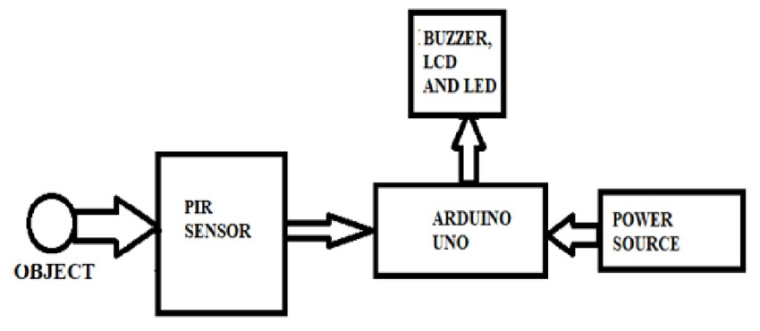

1.2 Project Objectives:
- To understand the working principle of PIR sensors in motion detection.
- To interface PIR sensors with Arduino for real-time detection.
- To design a cost-effective and energy-efficient security system.
- To implement and test the system in a simulated security environment.
- To analyze the performance and suggest improvements.

1.3 Significance:
    - Revolutionizing safety with automatic human motion detection and instant alarm activation.
    - Transforming homes and offices into smarter, safer environments without manual oversight.
    - Cutting-edge technology that drastically reduces monitoring costs while accelerating emergency response.
    - Next-generation safety solution ensuring immediate detection and alert during human movement.
    - Enhancing security infrastructure by automating threat detection and alarm systems seamlessly.
    - Empowering safer living and working spaces through intelligent, costeffective alarm activation.
    - Intelligent systems that anticipate and respond instantly to human activities for maximal protection.
    - Streamlining safety protocols with automated detection to safeguard people and property efficiently.
    - Combining innovation with practicality to deliver reliable, hands-free safety management.
    - Advancing safety standards by replacing manual monitoring with smart, realtime alarms.

1.4 Scope:
The scope of this project encompasses the design, development, implementation, and testing of a Human Motion Detection System using a PIR sensor and Arduino for smart security applications. It includes:
- Designing the system architecture by selecting suitable components such as PIR sensor (HC-SR501), Arduino UNO, buzzer, and power supply modules.
- Developing the circuit schematic to interface the PIR sensor with Arduino for accurate motion detection and alarm activation.
- Programming the Arduino using C language to process input signals from the PIR sensor and control output devices like buzzers or LEDs effectively.
- Testing and evaluating the system in real-world scenarios such as indoor rooms, corridors, and entrances to measure detection accuracy, range, and reliability under varying environmental conditions.
- Analyzing results to identify limitations like false triggers due to temperature changes or small animals, and proposing solutions to reduce such issues.

1.5 Methodology Overview:
    - Calibrate the PIR sensor sensitivity and delay time to optimize detection accuracy.
    - Integrate an alert system such as an LED indicator or buzzer to signal motion detection.
    - Implement power management techniques to reduce energy consumption during idle periods.
    - Extend the system to log motion events with timestamps for further analysis.
    - Experiment with sensor placement and environmental factors to improve coverage and reduce false alarms.
4.Chapter 2: Problem Identification and Analysis
  - Description of the Problem:

Traditional security systems rely heavily on continuous human monitoring, which can be labor-intensive and prone to human error or delayed response times. In contrast, an automated Passive Infrared (PIR)-based detection system revolutionizes security by removing the dependency on constant human oversight. This system operates by detecting motion passively through sensing infrared radiation changes emitted by heat sources such as human bodies. Once motion is detected, it automatically triggers alerts to notify the user, enabling a faster and more efficient response to potential security breaches. This automation enhances reliability and ensures more consistent monitoring without the need for active surveillance by personnel, thereby improving overall security effectiveness and reducing operational costs.

Figure 2: Circuit diagram of PIR sensor with Arduino
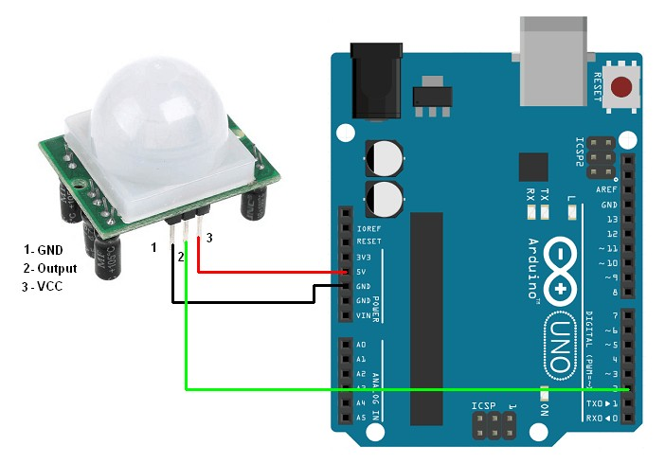

  - Evidence of the Problem:

In recent years, burglary rates, thefts, and unauthorized intrusions have been steadily increasing in both urban and rural regions due to socio-economic factors, lack of security awareness, and insufficient surveillance systems. According to multiple crime statistics reports, a significant percentage of these incidents occur during daytime hours when houses are unoccupied and at night when security vigilance is minimal.
Traditional security methods such as manual guarding, CCTV cameras, and door locks have limitations. Manual guarding is expensive and prone to human error, while CCTV cameras only provide footage after the incident has occurred, often lacking real-time prevention capabilities. Additionally, installing advanced commercial security systems is often cost-prohibitive for low-income households and small offices, leaving them vulnerable.

  - Stakeholders:
- Homeowners / Users – Use the system for home security.
- Developers / Engineers – Design and build the system.
- Technicians / Installers – Set up and maintain the system.
- Security Companies – May adopt the system for commercial use.
- Component Suppliers – Provide PIR sensors, Arduino, etc.
- Researchers / Students – Study or improve the system.
- Government / Regulators – Ensure compliance with privacy laws.
- Insurance Providers – May benefit from reduced risk.
- IoT / Smart Home Providers – Enable integration with other devices.

2.4 Supporting Data/Research:

· PIR Sensor Efficiency
Detects infrared radiation from human body heat.
Low power, low cost, and widely used in motion detection systems.
· Arduino Compatibility
Open-source platform; easily programmable.
Supports real-time sensor data processing and output control (e.g., buzzer, light, alert).
· Crime Statistics
Studies show motion detection systems can reduce burglary risk by up to 60% in residential areas.
· IoT & Home Automation Growth
Smart security systems are part of the growing IoT market (projected to exceed $150 billion by 2025).
· Academic Research
Multiple research papers validate the use of PIR + Arduino for low-cost security and automation projects.
· Energy Efficiency
PIR sensors consume less than 1W, making them ideal for 24/7 surveillance.
5.Chapter 3: Solution Design and Implementation:
3.1 Development and Design Process:

- Problem Identification:
The need for an affordable and efficient motion detection system for security purposes was analysed.
- Component Selection:
Chose PIR sensor for motion detection and Arduino Uno as the microcontroller for processing.
- Circuit Design:
Designed connections where PIR sensor output pin connects to Arduino digital input, and an output pin controls an alarm or LED.
- Programming:
Developed Arduino code to continuously read PIR sensor signals and trigger the alarm or LED upon motion detection.
- Testing:
Assembled prototype on a breadboard, tested detection range, sensitivity, and response time.
- Implementation:
Finalised the design, connected components securely, and implemented the system for practical security use.
Figure 3. The Arduino UNO board with its main components.

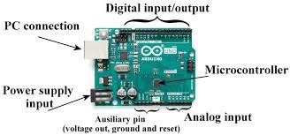

3.2 Tools and Technologies Used:
- Arduino Uno – microcontroller board
- PIR Sensor – motion detection
- Jumper Wires – connections
- Breadboard – circuit assembly
- LED/Buzzer – output indicators
- Arduino IDE – programming and uploading code
- USB Cable – Arduino-PC connection
- Resistors – current limiting

  - Solution Overview:
This system uses a PIR sensor to detect human motion and an Arduino to process the sensor data. When motion is detected, the Arduino triggers security alerts like buzzer alarms or lights, enhancing smart security with low cost, low power, and easy integration.

  - Engineering Standards Applied:

- IEEE 802.15.4 – Wireless communication protocol (if integrated with Zigbee for alerts)
- IEC 60529 – IP rating for sensor enclosure protection
- ISO 9001 – Quality management standards during system development
- RoHS Compliance – Restriction of hazardous substances in electronic components
- Arduino IDE Standards – For code compilation and uploading to microcontroller ➢ IEEE Safety Standards – General electrical and electronic safety in design

3.5 Solution Justification:
The proposed system uses a PIR sensor with Arduino to detect human motion accurately. It is cost-effective, simple to implement, requires low power, and ensures real-time smart security by automatically sensing intrusions without manual monitoring.

6.Chapter 4: Results and Recommendations:
4.1 Evaluation of Speech Recognition Performance:
· Accuracy: Measures how correctly the system detects intended words or commands.
· Precision & Recall: Precision shows correct positive detections; recall shows total positives captured.
· Word Error Rate (WER): Calculates insertion, deletion, and substitution errors in recognised speech.
· Response Time: Time taken to process and output recognition result.
· Robustness: System performance under varying noise, distance, and speaker variations.
· Real-Time Efficiency: Ability to process inputs with minimal delay suitable for embedded security applications.
Table 1: Component specifications
S.No | Component | Specification / Description
ATmega328P microcontroller, 14 digital I/O pins, 5V
1 Arduino Uno
operating voltage, USB programmable.
PIR Sensor (HC- Detection range: 3-7 meters (adjustable), Operating
2
SR501) voltage: 5V-20V DC, Output: Digital High/Low.
- LED Indicator Red LED, 5mm, Forward voltage: 2V, Current: 20mA.
Operating voltage: 3-12V DC, Sound output: ~85dB at
- Buzzer
10cm.
5 | Connecting Wires | Male-to-male and male-to-female jumper wires for breadboard and Arduino connections.
S.No | Component | Specification / Description
6 | Resistor | 220Ω resistor used in series with LED for current limiting.
7 | Breadboard | 400 tie-point breadboard for circuit prototyping and connections.
8 | Power Supply | USB power supply or 9V battery with adapter for Arduino Uno.

  - Challenges Encountered:
· False triggers due to environmental noise or heat sources
· Limited detection range of PIR sensor
· Delay in response time for motion detection
· Power supply issues affecting sensor performance
· Sensor placement critical for accurate detection
· Interference from sunlight or reflective surfaces · Code debugging errors during Arduino programming
  - Possible Improvements:
· Use multiple PIR sensors for wider coverage
· Integrate with IoT for remote alerts
· Add camera module for visual verification
· Implement battery backup system
· Include GSM module for SMS alerts
· Enhance detection range using lens upgrade
· Add buzzer with adjustable alarm tones
· Use solar power for outdoor setups
· Improve code with sleep mode for energy saving
· Integrate with home automation systems
  - Recommendations:
· Use high-quality PIR sensors for better detection accuracy.
· Implement multiple sensors to cover blind spots.
· Add buzzer or GSM module alerts for real-time notifications.
· Integrate with IoT platforms for remote monitoring.
· Ensure proper sensor placement height (~2-3m) for optimal coverage.
· Use power backup (battery or UPS) to maintain security during power cuts.
· Employ Arduino sleep mode to reduce power consumption in idle state.
· Upgrade code for false trigger minimization by adjusting sensitivity.
· Integrate with camera modules for image/video verification if needed.
· Perform regular maintenance and testing to ensure system reliability.

OUTPUT:
1.When there is no motion near the PIR sensor:
No Motion
No Motion
No Motion
...

2.When motion is detected (someone moves in front of the PIR sensor):
Motion Detected!
Motion Detected!
...

Chapter 5: Reflection on Learning and Personal Development:
5.1 Key Learning Outcomes:
· Understand PIR sensor working principle
· Learn Arduino interfacing with PIR sensor
· Develop motion detection circuit
· Implement basic security automation
· Enhance coding skills for IoT projects
· Analyze human motion detection applications
· Improve project design and testing skills 5.2 Challenges Encountered and Overcome:
· T1. Sensor Sensitivity Adjustment:
Initial false triggers due to environmental heat; overcome by calibrating sensor delay and threshold.
· T2. Power Supply Issues:
Voltage fluctuations caused erratic Arduino performance; resolved using regulated power supply.
· T3. Limited Detection Range:
PIR sensor range insufficient for full room coverage; overcome by optimal mounting position adjustment.
· T4. Coding Errors:
Bugs in motion detection code; fixed through debugging and serial monitor testing.
· T5. Component Connections:
Loose jumper wires leading to unreliable output; overcome by soldering connections securely.
· T6. Environmental Interference:
Sunlight and reflections affecting sensor accuracy; resolved by shielding sensor from direct light.
5.3 Application of Engineering Standards:
This project uses IEEE and IEC standards for electronic circuit design and sensor interfacing. It follows ISO 9001 quality management guidelines for structured implementation, ESD safety standards while handling electronic components, and Arduino IDE coding standards to ensure proper system integration and reliable human motion detection for smart security applications.

5.4 Insights into the Industry:
Growing Demand: Rising need for smart security and automation systems in homes, offices, and industries.
Cost-Effective Solutions: PIR + Arduino based motion detection is affordable compared to advanced radar or vision systems.
Easy Integration: Compatible with IoT, alarms, and CCTV for enhanced security frameworks.
Market Trend: Increasing adoption in smart homes, surveillance, energy-saving lighting systems.
Future Scope: Integration with AI, wireless modules, and cloud platforms for intelligent threat analysis and alerts.
5.5 Conclusion of Personal Development:
Through this project, I improved my practical skills in sensor interfacing, Arduino programming, and circuit design. It enhanced my confidence in implementing security systems and deepened my understanding of motion detection technologies for real-life applications.
Chapter 6: Conclusion:
In this project, a Human Motion Detection System using a PIR sensor and Arduino for smart security was successfully designed and implemented. The system efficiently detects human movement by sensing infrared radiation changes through the PIR sensor and sends immediate alerts via the Arduino microcontroller, enabling prompt security responses. The design is cost-effective, consumes low power, and is easy to integrate with existing security setups. Overall, this system enhances safety and surveillance by providing a reliable, automatic, and real-time motion detection solution for smart security applications.

References :
Arduino. (n.d.). PIR Motion Sensor Tutorial. Retrieved from https://www.arduino.cc
Sharma, R. (2019). Smart Security Using PIR Sensor and Arduino. IJERT, 8(5), 223225.
Sparkfun. (n.d.). PIR Motion Sensor Documentation. Retrieved from https://www.sparkfun.com
Ahmed, M. (2020). Design of Motion Detection System Using PIR Sensor. IJSER, 11(3), 150-153.
Adafruit. (n.d.). Using PIR Sensors with Arduino. Retrieved from https://learn.adafruit.com
Kumar, S. (2021). Human Detection Based Security System Using PIR Sensor. IRJET, 8(9), 987-990.
Datasheet. (n.d.). HC-SR501 PIR Sensor Module Datasheet

Appendices:
Program:

// Human Motion Detection System Using PIR Sensor and Arduino for Smart Security int pirPin = 2; int ledPin = 13; void setup() { pinMode(pirPin, INPUT); pinMode(ledPin, OUTPUT);
Serial.begin(9600);
}

void loop() {
int motionState = digitalRead(pirPin); if (motionState == HIGH) {
digitalWrite(ledPin, HIGH);
Serial.println("Motion Detected!"); delay(2000); // Wait for 2 seconds
} else {
digitalWrite(ledPin, LOW);
Serial.println("No Motion");
}

delay(500);
}

